Page 1: Home.
1. Welcome message
Welcome to my portfolio. I’m Sara, a software engineering technology student with a background in interior design, visual creativity, and digital projects.
2. Mission statement
My goal is to combine design, technology, and problem-solving to create digital experiences that are useful, clean, and visually thoughtful.
3. Button/link text
View My Projects

Page 2: About Me
1. Legal name
Sara Rouane
2. Professional photo

3. Resume PDF
4. About Me paragraph
My name is Sara [Last Name], and I am currently studying Software Engineering Technology with a focus on web development and artificial intelligence. I also have a background in interior design, which has helped me develop strong creative, visual, and problem-solving skills. I enjoy learning new technologies, building practical solutions, and combining design with technical knowledge to create engaging user experiences.

Page 3: Projects
Project 1 — Interior Design Project
Title: Interior Design Concept
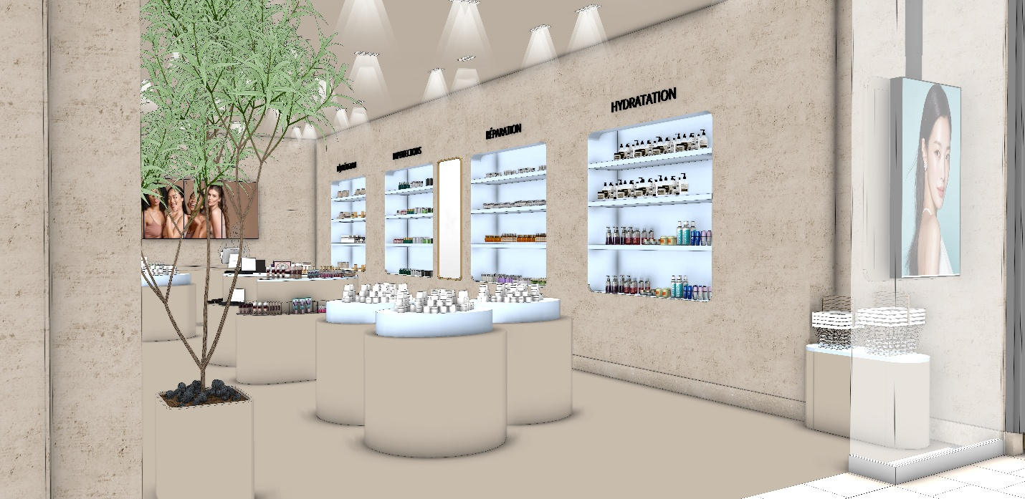
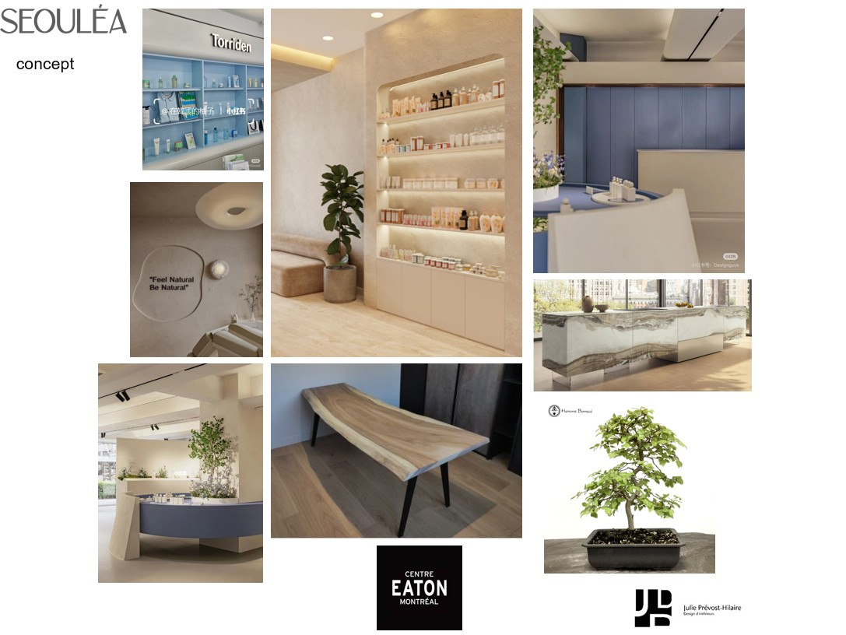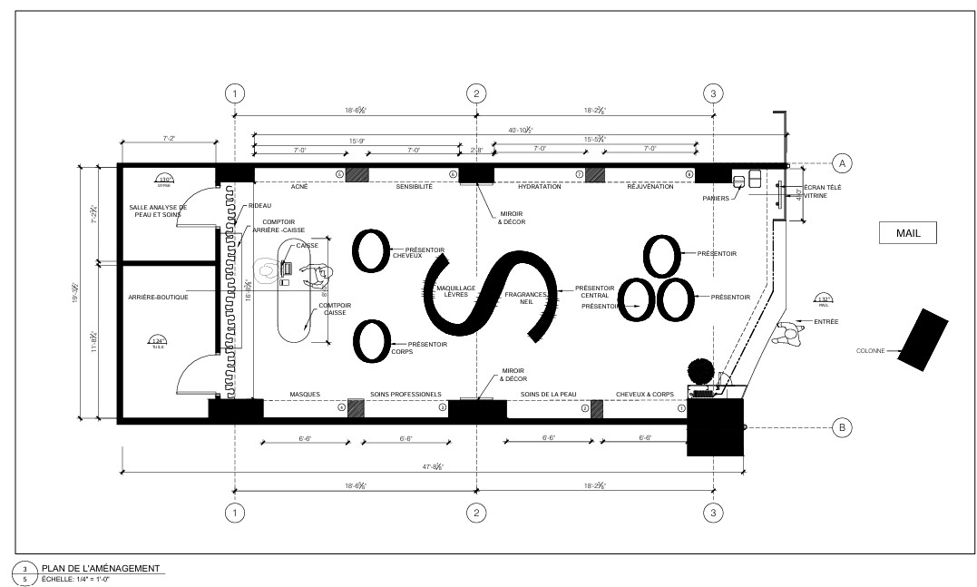


Description:
Helped developed a comercial interior design concept, including space planning, material selection, and 3D visualization.
Role:
Interior Designer
Outcome:
Produced presentation drawings and realistic renderings to communicate the final design concept.
Completion Date:
Sep/2025

Project 2 — School Software Project
Project Title: Canadian Tech Event Registration Form
Completion Date: April 2026
Role: Front-End Web Developer
Description:
This project was developed as part of a web development course. The goal was to create an interactive registration form for a technology event using HTML, CSS, and JavaScript. The form collects user information, validates input fields, and provides feedback when information is missing or entered incorrectly.
Outcome:
The final application successfully captures user input, validates form entries, and submits data through an API request. This project strengthened my understanding of form design, JavaScript validation, and responsive web development.
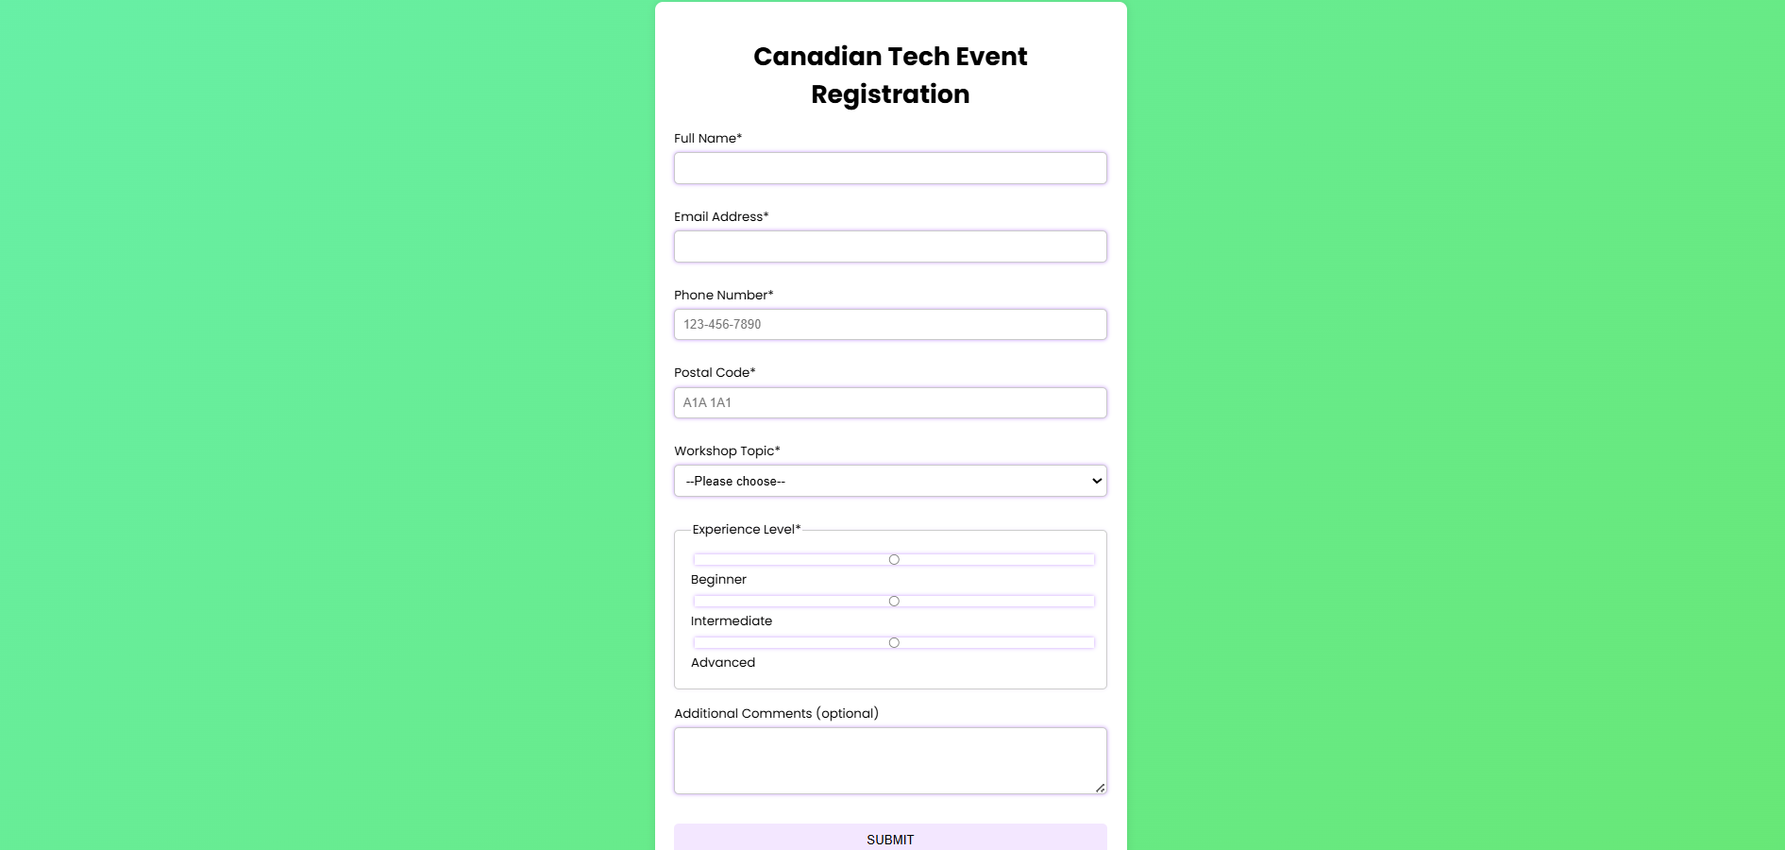
Project 3
Project Title: Vision Room Project
Completion Date: 2026
Role: Project Planner and Designer
Description:
The Vision Room Project was developed for an IT Management course and focused on designing a workspace that supports productivity, creativity, and long-term goal achievement. The project involved researching user needs, planning the physical environment, and proposing technology solutions that would improve the overall experience of the space.
Outcome:
The project resulted in a complete concept proposal that combined planning, design, and technology considerations. It demonstrated the importance of aligning environment, tools, and user needs when developing effective solutions.
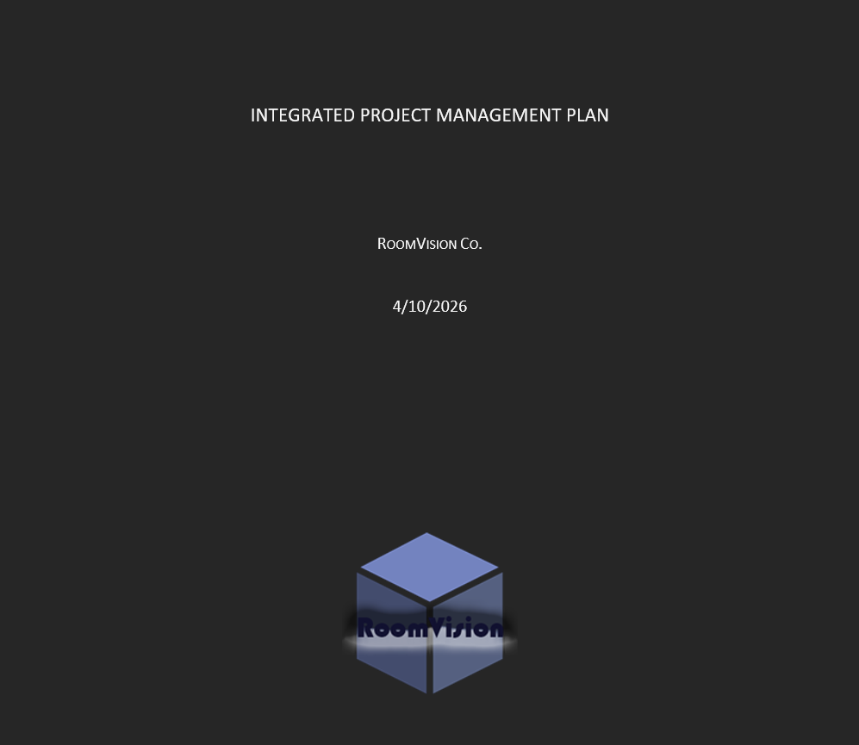

Title: Vision Room Project
Description:
Developed a digital concept for a Vision Room as part of an IT Management course. The project focused on planning, organization, technology integration, and creating a functional environment that supports productivity and long-term goals.
Role:
Project Planner and Designer
Outcome:
Helped produce a complete project proposal and visual concept demonstrating planning, analysis, and design skills.

Image Needed:
- Screenshot of the application
- Screenshot of code
- Screenshot of interface
Description:
Developed a software solution as part of a Software Engineering Technology course.
Role:
Software Developer
Outcome:
Successfully implemented required functionality and met project objectives.
Completion Date:
Month/Year

Page 4: Services
Service Title: Web Development
Description:
Development of responsive and user-friendly websites using HTML, CSS, JavaScript, and modern web technologies. I focus on creating clean interfaces, interactive features, and accessible user experiences that meet project requirements.

Service Title: Interior Design & Space Planning
Description:
Creation of functional and visually appealing interior environments through space planning, concept development, mood boards, and 3D visualization. My approach combines creativity with practical design solutions tailored to user needs.

Service Title: Project Planning & Digital Solutions
Description:
Planning and organizing projects by identifying requirements, developing concepts, and creating structured solutions. This includes research, documentation, workflow planning, and the integration of technology to support project goals.

Page 5: References
Reference 1
Name: Julie Prevost
Company: JPH Design
Position: Interior Designer / Project Manager
Testimonial:
Sara consistently demonstrates creativity, professionalism, and attention to detail in her design work. She approaches projects with a strong work ethic, adapts well to changing requirements, and contributes positively to the design process. I would confidently recommend her for opportunities that align with her skills and career goals.
Reference 2 (fictional)
Name: Michael Chen
Company: NorthStar Solutions
Position: Project Coordinator
Testimonial:
Sara is a reliable and detail-oriented professional who brings both creativity and organization to her work. She communicates effectively, approaches challenges with a problem-solving mindset, and consistently delivers quality results. Her ability to combine design thinking with technical knowledge makes her a valuable contributor to any project team.

Page 6: Contact
First Name: __________

Last Name: __________

Phone: __________

Email: __________

Message:
____________________
____________________

[Send Message]
The assignment says the form doesn't need to actually send emails. It just needs to collect the information and redirect back to the Home page.

